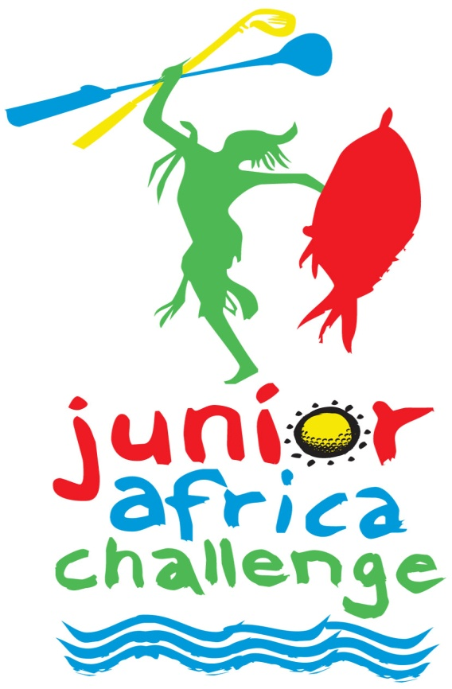
SCHEDULE OF EVENTS

Sunday, 22 August

14:00 - 17:00 hrs Registration: San Lameer Country Club - For those players who will be available at the club house on the day.

Monday, 23 August

Registration, Practice Round, Presentation: San Lameer Country Club:
- Registration: - The registration will be open from 09h00 – 15h00 hrs for all the players. If you already registered on Sunday, you do not have to re-register.
- Practice Round: - A free practise round is available on Monday, kindly contact San Lameer Country Club:
+27 (0) 39 313 5141, email: proshop@sanlameer.co.za . Pitch and play from 07h00 to 14h00 hrs.
- Opening Ceremony: - Due to Covid-19 restrictions there will be NO opening ceremony for 2021. There will however be the traditional 80m shootout from the clubhouse onto the 9th green for all players and a cash bar available for drinks and meals.

Please be advised that you MAY use a golf cart for the practise round at your own cost. No carts will be allowed during the tournament for players or caddies.

Tuesday, 24 August

Round One
Tee times will be available on our website, www.sakidsgolf.co.za and at San Lameer Country Club. Players and parents are advised to personally check pairing sheets to avoid mistakes or mishaps regarding tee times.

Wednesday, 25 August

Round Two
Players will be re-paired following the first round. Tee times for the second day will be posted on our website, www.sakidsgolf.co.za , and at San Lameer Country Club. Players and parents are advised to personally check pairing sheets.

Thursday,26 August

Round Three
Players will be re-paired following the second round, based on score. Tee times for the final round will be posted after the completion of play for each age/gender division on our website, www.sakidsgolf.co.za and at San Lameer Country Club. Once again, players and parents are advised to personally check pairing sheets.

Awards Ceremony: San Lameer Country Club
Due to Covid-19 restrictions, the awards presentations will be split between 9 and 18 holes, the 9 holes commencing around 12:00 and the 18 holes commencing around 17:00 at San Lameer Country Club on Thursday, August 26, after the official results are posted for each age group.

Friday, 27 August

Junior Africa Challenge Dunbar Cup
The Dunbar Cup will be contested at San Lameer Country Club from 08:00. The top two South African and top two International players among Boys 9 and older and Girls 10 and older per age group will compete against each other in a Ryder Cup Format. The winning team retains the Dunbar Cup until 2020. The SAKG Committee reserves the right to change the format of play depending on the number of international players available for the event.

